Table of Contents

CHAPTER 1: JAVA EE AND WEBSPHERE APPLICATION SERVER 2

Theory 2

AIM 10

SUMMARY 11

REFERENCES 12

# CHAPTER 1: JAVA EE AND WEBSPHERE APPLICATION SERVER

## Theory

**Java**

The term Java refers to two different things: an object-oriented programming and a platform where you can run applications developed using Java programming language.

Java, as a programming language, is concurrent, class-based and object-oriented with very few implementation dependencies. Java is compiled to bytecode format that can be executed on Java Virtual Machine (**JVM**). Ideally, applications can be developed on any device and executed on any platform that has JVM and this is explained by the slogan “*Write once, run anywhere*” (**WORA**).

Java, as a platform, is a bundle of programs that allow developing and running applications written in Java programming language. There are four platforms of Java programming language where each of them has a JVM and an application programming interface (API).

* Java Platform, Standard Edition, **Java SE**, is a widely used Java platform for development and deployment of applications for desktop and server environments. The API of Java SE provides the ore functionality of the Java programming language. Java SE has also a virtual machine, development tools, deployment technologies, and other class libraries and toolkits commonly used in Java technology applications.
* Java Platform, Enterprise Edition, **Java EE**, is the industry standard for developing portable, robust, scalable and secure server-side Java applications. Building on the solid foundation of Java SE, Java EE provides web services, component model, management, and communications APIs that make it the industry standard for implementing enterprise class service-oriented architecture (SOA) and Web 2.0 applications.  
    
  In the following figure, you can find the version history of Java EE and important milestones.  
  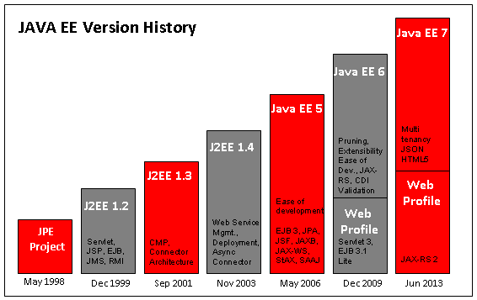
* Java Platform, Micro Edition, **Java ME**, is designed for mobile devices such as consumer products, embedded devices and mobile devices, and provides an API, which is a subset of the Java SE API with special class libraries.
* **JavaFX** is a platform for creating and delivering rich internet applications (RIA). It is possible to build applications that display information in a high-performance user interface using network resources.

Multi-tier Applications

An enterprise application is designed and developed to satisfy needs of an organization or to solve enterprise problems. These kinds of applications are usually multi-tiered, complex, distributed, scalable and critical. Although they interact with different networks and applications within the organization, they have to be highly secure.

Multi-tier architecture is a client-server architecture where client tier, middle tier (web tier and business tier) and data tier (or enterprise information systems tier) are physically separated.

***Client tier*** makes the request to middle tier and this request is processed in middle tier and then the response is sent back to the client. There can be web browsers, Java EE clients and containers in this tier.

***Web tier*** receives the request from client, and calls the business tier and sends the response back to client.

***Business tier*** is the core of the application. It provides the business logic of the application with interaction to the enterprise information systems tier.

***Enterprise Information Systems (EIS)*** tier contains resources such as database servers and legacy systems that are needed by business tier.

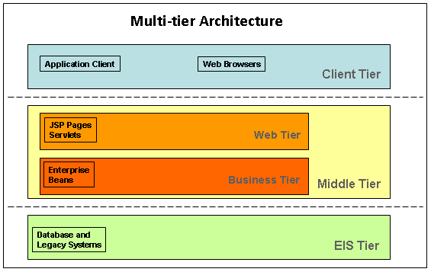

Java EE Application Servers

An application server is a Java EE based product that resides in the middle tier and provides the standard Java EE services. A Java EE application server meets all the requirements of enterprise applications and let developers focus on the business logic rather than on infrastructure and integration tasks.

Application servers allows you to serve application data to client tier using containers, which performs communication between different components that need to work together.

The ***Web Container*** is a part of an application server that manages servlets and JSP pages. It provides an interface between web components and the web server.

The ***Application Client Container*** includes a set of Java classes, libraries, and other files that are required for and distributed with Java client program. It runs on client machine and manages the execution of Java EE application client components.

The ***EJB Container***provides a run-time environment for enterprise beans in the application server. It handles the operations between the business logic in a Java EE application and the rest of the server components.

In the figure below, you can find the compatible application servers with Java EE 6 and Java EE 7.

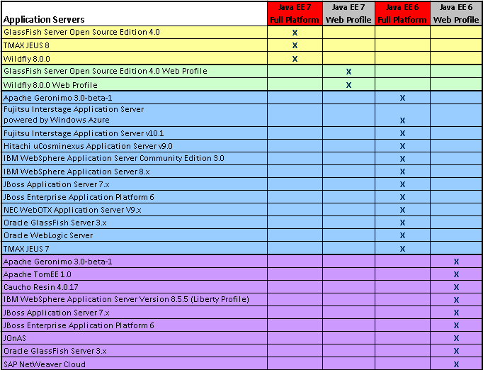

**WebSphere Application Server**

IBM WebSphere Application Server (WAS) is a middleware application that provides environment to implement service-oriented architecture (SOA) applications and services for your enterprise. It can run on multiple platforms such as Windows, AIX, Linux, Solaris, i/OS and z/OS. WAS can work with numerous web servers including Apache HTTP Server and Microsoft IIS, but IBM HTTP Server has certain advantages.

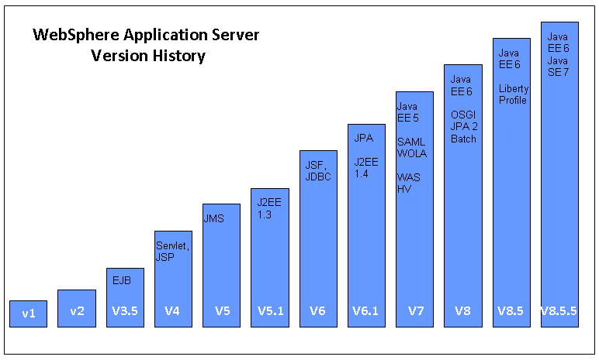

Because different business needs require different application server capabilities, WebSphere Application Server has different packaging options to fulfill the requirements of specific project or infrastructure. WAS also provides migration possibility between those different packaging options.

* ***WebSphere Application Server Express*** is targeted to small size dynamic applications that can run on a single server.
* ***WebSphere Application Server Base*** has the same functionality as Express package but it is different in terms of packaging and licensing*. The Tools Edition* is part of the Base packaging and includes unlimited number of licensing for IBM Rational Application Developer and WebSphere Application Server Developer Tools for Eclipse for application development
* ***WebSphere Application Server Network Deployment*** is targeted to mission critical enterprise applications providing advanced performance, management and high availability. The Tools Edition is also part of this packaging.
* ***WebSphere Application Server for z/OS*** is targeted to z/OS with the same functionality as Network Deployment packaging.
* ***WebSphere Application Server for Developers*** is targeted to developers who don’t use IBM Rational Application Developer and gives them opportunity to build and test their applications. It is free of charge.
* ***WebSphere Application Server Hypervisor Edition*** is targeted to run on VMware ESX or ESXi hypervisors. It provides a virtual machine image including a guest operating system and Network Deployment version of WebSphere Application Server.
* ***WebSphere Application Server Liberty Core*** is targeted to lightweight web applications that don’t require full Java EE capabilities.
* ***WebSphere Application Server Community Edition*** is built on Apache Geronimo with some extensions and is free of charge.

WebSphere Application Server started to have two different runtime profiles from version 8.5:

* ***Full WebSphere Application Server Profile*** provides Java EE 8 and Enterprise OSGI technologies. You can create generic server definitions to configure other servers or processes needed to support application server environment.
* ***Liberty Profile*** is a good option for developers who don’t need full Java EE environment. It has lightweight run time environment that provides low resource usage and simplified configuration. Any application that runs on Liberty Profile can also run on Full Server Profile.

Websphere Application Server supports following programming models:

* Java EE 8
* OSGi applications
* Web 2.0 Mobile
* WebSphere Batch
* XML
* Service Component Architecture (SCA)
* Communications Enabled Applications (CEA)
* Session Initiation Protocol (SIP)

What’s new in version 8.5?

WebSphere Application Server has following new features in version 8.5:

* The new Liberty profile option is a highly composable, fast to start, and ultra-lightweight profile of the application server and is optimized for developer productivity and web application deployment.
* Application Edition Management enables interruption-free application rollout. Applications can be upgraded without incurring outages to your end users.
* Health Management monitors the status of your application servers and is able to sense and respond to problem areas before end users suffer an outage. Problem areas include increased time spent on garbage collection, excessive request timeouts, excessive response time, excessive memory, and much more.
* Intelligent Routing improves business results by ensuring priority are given to business critical applications. Requests are prioritized and routed based upon administrator defined rules.
* Dynamic Clustering can dynamically provision and start or stop new instances of application server Java™ Virtual Machines (JVM) based on workload demands. It provides the ability to meet Service Level Agreements when multiple applications compete for resources.
* Enterprise Batch Workload support leverages your existing Java online transaction processing (OLTP) infrastructure to support new Java batch workloads. Java batch applications can be executed across multiple Java Enterprise Edition (Java EE) environments.
* IBM WebSphere SDK Java Technology Edition V8.0 as an optional pluggable Java Development Kit (JDK).
* Web 2.0 and Mobile Toolkit provides an evolution of the previous Feature Pack.
* Updated WebSphere Tools bundles provide the "right-fit" tools environment to meet varied development and application needs.
* For businesses that need to build, deploy, and manage secure and portable innovative applications that run on a multitude of mobile, server, and desktop systems, WebSphere Application Server is the flexible and efficient SOA application platform of choice.

## AIM

When you complete the all next chapters with lab exercises, you will be able to:

* Install WebSphere Application Server
* Integrate with IBM HTTP Server
* Deploy applications
* Run in clustered and highly available environment.

In addition to the points above, you will have the basic knowledge of:

* Administration
* Security
* Monitoring
* Troubleshooting in WebSphere Applicatin Server.

# SUMMARY

Java means both a programming language and a platform for enterprise applications. In order to make the development of enterprise applications, multi-tier architecture is used and each tier of this architecture corresponds with a Java EE container. WebSphere Application Server is an application server that contains open standards for application development and deployment. WAS is certified for Java EE 8 full platform and Java EE Web Profile with Liberty profile. With version 9, there are many new features are introduces such as Intelligent Management and dynamic clustering.

# REFERENCES

* http://docs.oracle.com/javaee/8/tutorial/doc/bnaaw.html
* http://www.oracle.com/technetwork/java/javaee/overview/compatibility-jsp-136984.html
* http://www-03.ibm.com/software/products/en/was-overview
* http://www-01.ibm.com/software/websphere/subscriptionandsupport/compare-was-versions.html